

**Department of Electronics and Communication Engineering**

**III IA EVALUATION REPORT**

***for***

**BLENDED LEARNING PROJECT BASED LEARNING**

***A report submitted by***

|  |  |
| --- | --- |
| ***Name of the Students*** | ***SANJAY PRABU M V, BAVIN B*** |
| ***Register Numbers*** | ***URK22EC1062& URK22EC1038*** |
| ***Subject Name*** | ***DIGITAL COMMUNICATION*** |
| ***Subject Code*** | ***22EC2016*** |
| ***Date of Report submission*** |  |

**Project Rubrics for Evaluation**

**First Review:** to be awarded for **10 Marks** – PPT should have four slides (Title page, Introduction, Circuit/Block Diagram, and Description of Project).

**Second Review:** to be awarded for **10 Marks** – PPT should have three slides (Description of Circuit/Concept, Design of Circuit in Tools/Design of Flow graph, and Partial Results)

**Third Review:** to be awarded for **10 Marks** – PPT should have two slides (Tool based simulation/Hardware based simulation/Concept based interaction/ Case Study)

**Fourth Review:** to be awarded for **10 Marks** –PPT should have two slides (Output Results & Discussion)

**[NOTE: The instructions are subjected to change if required to combine either of two reviews and to be evaluated for 20 Marks.]**

**Total marks:_____/ 40 Marks**

**Signature of Faculty with date:**

### Design of Composite signal using CDMA Transmitter

### A project report submitted by

**SANJAY PRABU M V(URK22EC1062)**

**BAVIN B(URK22EC1038)**

### In partial fulfillment for the award of the degree

### of

**BACHELOR OF TECHNOLOGY**

**For**

**DIGITAL COMMUNICATION**

**– PROJECT BASED LEARNING(22EC2016)**

***Under the supervision of***

**Dr.S. Merlin Gilbert Raj**

**DEPARTMENT OF ELECTRONICS AND COMMUNICATION ENGINEERING**

# KARUNYA INSTITUTE OF TECHNOLOGY AND SCIENCES

#### (Deemed-to-be-University)

**KarunyaNagar, Coimbatore- 641114.INDIA**

**October 2023**

# BONAFIDECERTIFICATE

This is to certify that the project report entitled **“CDMA Transmitter”**is the bonafide work of**“SANJAY PRABU M V (URK22EC1062) and BAVIN B-(URK22EC1038)”**who carried out the project work under my supervision.

**SIGNATURE** **SIGNATURE**

DR.JUDE HEMANTH DR.S.MERLIN GILBERT RAJ

**HEAD OF THE DEPARTMENT** **SUPERVISOR**

PROFESSOR ASSISTANT PROFESSOR

Department of Department of ECE

School of E&T School of E&T

Submitted for the III Internal-Project Based LearningVivaVoceheldon _______________.

**InternalExaminer**



**TABLE OF CONTENTS**

|  |  |  |
| --- | --- | --- |
| **CHAPTER** | **TITLE** | **PAGE NO.** |
|  | **INTRODUCTION** | **5** |
|  | **PROBLEM STATEMENT& GRAPHICAL**  **ABSTRACT** | **6** |
|  | **DESCRIPTION OF THE PROJECT** | **9** |
|  | **CONCEPT INVOLVED** | **12** |
|  | **DESIGN& MATHEMATICAL MODEL** | **16** |
|  | **BLOCK DIAGRAM / FLOW CHART** | **22** |
|  | **PYTHON CODE** | **23** |
|  | **RESULT WITH GRAPH** | **30** |
|  | **CONCLUSION** | **33** |
|  | **REFERENCE** | **34** |

**CHAPTER 1**

**INTRODUCTION**

Code Division Multiple Access (CDMA) is a widely used wireless communication technology that enables multiple users to share the same communication channel by assigning unique pseudo-noise (PN) codes to each user. CDMA operates on the principle of spread spectrum, where each user’s signal is spread over a wide bandwidth using a specific code. This allows multiple users to transmit simultaneously without interference, as their signals remain distinct. The technology relies on orthogonal codes, which ensure that even when signals overlap, they can be separated during decoding. Qualcomm was a key player in the development and deployment of CDMA, which became the foundation of 3G cellular networks, such as CDMA2000 and W-CDMA. CDMA supported higher data rates, more users, and better bandwidth efficiency compared to earlier technologies like TDMA and FDMA.In addition to cellular networks, CDMA’s ability to minimize interference and enhance security made it valuable in military communications and satellite systems. One of its key advantages was the use of soft handoffs, which allowed seamless transitions between base stations, improving call reliability. However, CDMA also faced challenges, such as multi-user interference if codes were not perfectly orthogonal, and the near-far problem, where strong signals could overshadow weaker ones. Power control algorithms were introduced to address these issues by balancing signal strengths among users.With the shift to 4G LTE and 5G technologies, CDMA’s prevalence has declined, as newer systems use Orthogonal Frequency Division Multiple Access (OFDMA), which better supports high-speed data and low latency requirements. Despite this, CDMA remains relevant in niche areas like military and satellite communications, where its robustness and security are still valued.

**CHAPTER-2**

**PROBLEM STATEMENT& GRAPHICAL ABSTRACT**

**Problem Statement**

The problem statement for a Code Division Multiple Access (CDMA) transmitter revolves around the challenge of enabling multiple users to communicate over the same wireless frequency spectrum without causing interference. In traditional communication systems, bandwidth is allocated by dividing frequencies (FDMA) or time slots (TDMA) among users, which limits the number of simultaneous users. CDMA seeks to overcome these limitations by assigning unique pseudo-noise (PN) codes to each user, spreading their signals across a wide frequency spectrum.

The key issue addressed by CDMA is how to efficiently use the available bandwidth while maintaining signal clarity and user capacity. Each user’s data is modulated with a unique code that spreads the signal over the available bandwidth, allowing multiple signals to coexist. The challenge lies in ensuring that the spreading codes are orthogonal or pseudo-orthogonal, so that each user’s signal can be separated at the receiver without interference, even if they overlap in time and frequency.

Additionally, CDMA systems must deal with multi-user interference (MUI), power control issues (to prevent strong signals from overpowering weaker ones), and the "near-far" problem, where users closer to the base station could drown out those farther away. Overall, the problem statement for a CDMA transmitter focuses on how to maximize the number of simultaneous users while minimizing interference and maintaining communication quality across a shared frequency band, making it a robust and scalable solution for wireless communication systems.

**Graphical Abstract**

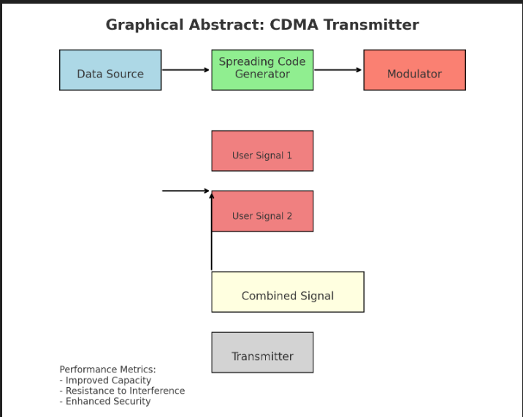

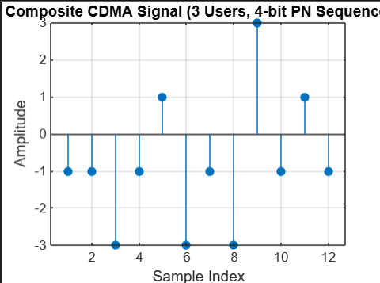

**Inference:**

The CDMA transmitter efficiently enables multiple users to share the same communication channel by encoding their data with unique Pseudo-Noise (PN) codes, which enhances bandwidth utilization.

**CHAPTER-3**

**DESCRIPTION OF THE PROJECT**

The objective of a CDMA (Code Division Multiple Access) transmitter is to enable multiple users to share the same communication channel simultaneously without significant interference by assigning each user a unique spreading code. This approach minimizes the impact of interference from other users, enhances bandwidth efficiency by spreading signals across a wider frequency range, and improves resilience against noise and fading in wireless channels. Additionally, CDMA provides a level of security through code-based transmission, allows for scalability by accommodating varying numbers of users without needing extra bandwidth, and maintains an acceptable quality of service by managing power levels and interference. Overall, the CDMA transmitter aims to facilitate reliable communication while maximizing resource utilization in diverse applications.

**Implementation of a CDMA Transmitter**

**1. Introduction:**

This section introduces the concept of CDMA (Code Division Multiple Access) and its significance in communication systems. It explains how CDMA allows multiple users to share the same communication channel by assigning unique spreading codes to each user’s signal.

**2. Objectives:**

Outline the objectives of implementing a CDMA transmitter, including:

- Efficient utilization of available bandwidth.

- Minimization of interference among users.

- Robustness against noise and fading.

- Scalability to accommodate varying numbers of users.

**3. Parameters Configuration:**

Discuss the parameters needed for the implementation:

* Number of Users : The total number of simultaneous transmitters in the system.
* Message Length : The length of each user's binary message.
* Chip Length : The length of the spreading code that will be used to spread each user’s signal.
* Signal-to-Noise Ratio (SNR) :The level of noise in the communication channel.

**4. Message Generation:**

Explain the process of generating random binary messages for each user. Each user’s message will serve as the information that needs to be transmitted.

**5. Spreading Codes Definition:**

Describe how unique spreading codes are created for each user. These codes can be orthogonal sequences like Walsh codes, which help in spreading the user’s signal across a wider frequency range, enabling simultaneous transmission.

**6. Spreading Process:**

Detail the method of spreading each user's message using their corresponding spreading code. This involves multiplying the user's binary message by the spreading code to create a wider bandwidth signal.

**7. Signal Combination:**

Explain the process of combining all users’ spread signals into a single composite signal for transmission. This section discusses how the individual signals are summed together to form one signal that will be sent over the communication channel.

**8. Modulation:**

Describe the modulation technique used, such as BPSK (Binary Phase Shift Keying). Explain how the combined signal is modulated for transmission, converting the spread signal into a form suitable for sending over the channel.

**9. Noise Addition:**

Discuss the addition of noise to the modulated signal to simulate real-world communication conditions. Explain the significance of including noise in the model and how it affects the transmission quality.

**10. Visualization:**

Outline the process of visualizing the spread signals of each user and the resulting noisy combined signal. Explain the importance of visual representation for understanding the behavior of the transmitted signals.

**11. Results Display:**

Discuss how to present the original messages and the spread signals to observe the effects of the spreading process and the impact of noise on the transmitted signal.

**12. Conclusion:**

Summarize the key points of the CDMA transmitter implementation, emphasizing its effectiveness in allowing multiple users to communicate simultaneously. Discuss potential areas for further exploration, such as error correction techniques, receiver design, and applications of CDMA in modern communication systems.

.**Tools and Libraries:**

**1. MATLAB**

Communications System Toolbox

* **randi**: Generates uniformly distributed random integers.
* **sum**: Adds elements of arrays.
* **awgn**: Adds white Gaussian noise to a signal, simulating channel effects.
* **plot**: Visualizes data.

**Expected Outcome:**

The expected outcomes of the CDMA transmitter implementation include the generation of random binary messages for multiple users, along with unique orthogonal spreading codes to minimize interference. This process will produce spread signals that expand the original messages, leading to a combined signal that incorporates all users’ contributions. The combined signal will be modulated (e.g., using BPSK) and will include a noisy version that simulates real-world conditions with additive white Gaussian noise (AWGN). Visualizations will illustrate individual spread signals, the combined noisy signal, and comparisons with original messages. Performance analysis will provide insights into noise impact and system robustness, culminating in a report summarizing the implementation process and findings.

**CHAPTER-4**

**CONCEPT INVOLVED**

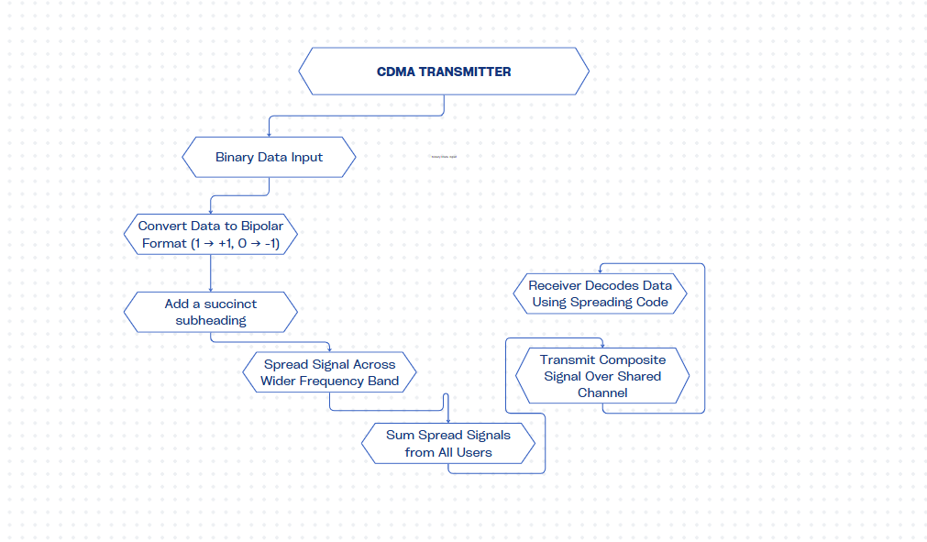

**1. Code Division Multiple Access (CDMA):**

CDMA is a multiple access technique that allows multiple users to transmit information simultaneously over the same frequency channel. It achieves this by assigning unique spreading codes to each user, enabling their signals to coexist without causing interference.

**2. Spreading Codes:**

Spreading codes are sequences used to modulate the user's signal, effectively expanding its bandwidth. Each user is assigned a unique code, which is typically orthogonal to the codes of other users. This orthogonality ensures that the signals can be separated at the receiver even when transmitted simultaneously.

**3. Spread Spectrum Technology:**

CDMA employs spread spectrum technology, where the transmitted signal occupies a broader frequency band than the minimum bandwidth required. This spreading increases resistance to interference and jamming, enhancing communication reliability.

**4. BPSK Modulation:**

Binary Phase Shift Keying (BPSK) is a modulation scheme commonly used in CDMA systems. In BPSK, each bit of data is represented by a change in the phase of the carrier signal. This method allows for effective transmission of digital data while being resilient to noise.

**5. Signal Combination:**

In a CDMA transmitter, the individual spread signals of multiple users are combined into a single composite signal before transmission. This summation allows all users to share the same frequency band while maintaining the integrity of their individual signals.

**6. Additive White Gaussian Noise (AWGN):**

AWGN is a statistical model of the noise affecting the signal during transmission. It is characterized by a constant spectral density and is commonly used to simulate real-world communication conditions. Understanding its impact is crucial for analyzing system performance.

**7. Receiver Processing:**

At the receiver end, the process involves demodulating the received signal using the same spreading codes to retrieve the original messages. This step is critical for differentiating between the signals of multiple users and ensuring accurate data recovery.

**8. Interference Management:**

CDMA inherently manages interference through the use of spreading codes. The unique codes help to minimize cross-talk between users' signals, allowing the system to function effectively even in environments with high user density.

**9. Scalability:**

One of the key advantages of CDMA is its scalability. As more users are added to the system, the unique spreading codes enable continued performance without requiring additional bandwidth, making it suitable for growing communication networks.

**10. Applications of CDMA:**

CDMA technology is widely used in various communication systems, including cellular networks, satellite communications, and wireless local area networks (WLANs). Its ability to support multiple simultaneous users makes it a cornerstone of modern telecommunications.

**CHAPTER-5**

**DESIGN & MATHEMATICAL MODEL**

Designing a Code Division Multiple Access (CDMA) transmitter involves creating a system that can simultaneously transmit signals from multiple users over the same frequency channel, using unique spreading codes. Below is a description of the design and the mathematical model for a CDMA transmitter.

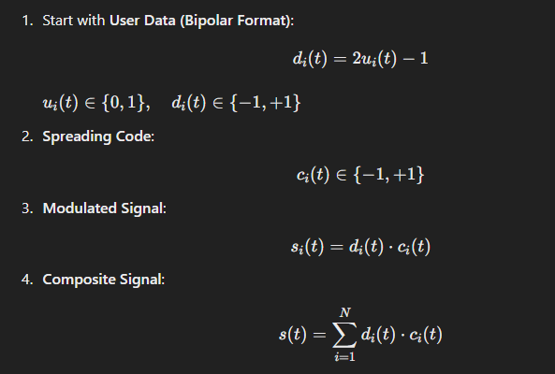

## Design of CDMA Transmitter

### 1. ****System Components****

* **User Input**: Each user generates a binary message that needs to be transmitted.
* **Spreading Code Generator**: Unique spreading codes are generated for each user. These codes are typically orthogonal to minimize interference.
* **Signal Modulator**: The spread signal is modulated using a modulation technique, such as BPSK (Binary Phase Shift Keying).
* **Combiner**: All users' modulated signals are combined into a single composite signal for transmission.
* **Channel**: The combined signal is sent over a communication channel, which may introduce noise.

### 2. ****Mathematical Model****

The mathematical model for a CDMA transmitter can be described using the following components:

#### 2.1. **User Messages**

Let mi(t)m_i(t)mi​(t) represent the message signal for the iii-th user, where:

* mi(t)m_i(t)mi​(t) is a binary message signal, defined over a time duration TTT.

#### **2.2. Spreading Codes**

Let ci(t)c_i(t)ci​(t) be the spreading code for the iii-th user, defined over the same duration TTT. The spreading code has a chip rate RRR, where each code has a length of NNN chips:

* ci(t)c_i(t)ci​(t) is typically a sequence of +1 and -1 values.

#### **2.3. Spread Signal**

The spread signal for the iii-th user, si(t)s_i(t)si​(t), can be represented as:

si(t)=mi(t)⋅ci(t)s_i(t) = m_i(t) \cdot c_i(t)si​(t)=mi​(t)⋅ci​(t)

Where:

* mi(t)m_i(t)mi​(t) is the message signal (0 or 1),
* ci(t)c_i(t)ci​(t) is the spreading code.

#### **2.4. Combined Signal**

The combined signal S(t)S(t)S(t) for all KKK users can be expressed as:

S(t)=∑i=1Ksi(t)=∑i=1Kmi(t)⋅ci(t)S(t) = \sum_{i=1}^{K} s_i(t) = \sum_{i=1}^{K} m_i(t) \cdot c_i(t)S(t)=i=1∑K​si​(t)=i=1∑K​mi​(t)⋅ci​(t)

#### 2.5. **Modulation**

Assuming BPSK modulation, the modulated signal Sm(t)S_m(t)Sm​(t) becomes:

Sm(t)=∑i=1K(2mi(t)−1)⋅ci(t)S_m(t) = \sum_{i=1}^{K} (2m_i(t) - 1) \cdot c_i(t)Sm​(t)=i=1∑K​(2mi​(t)−1)⋅ci​(t)

Where:

* mi(t)m_i(t)mi​(t) is the binary message signal converted to BPSK format (0 → -1, 1 → 1).

#### 2.6. **Channel and Noise**

The transmitted signal passes through a channel that may introduce noise, represented as:

R(t)=Sm(t)+N(t)R(t) = S_m(t) + N(t)R(t)=Sm​(t)+N(t)

Where:

* R(t)R(t)R(t) is the received signal,
* N(t)N(t)N(t) is the noise, typically modeled as Additive White Gaussian Noise (AWGN).4. **Performance Metrics**

The performance of the CDMA transmitter can be analyzed using metrics such as:

* **Bit Error Rate (BER)**: The probability of bit errors in the transmitted messages.
* **Signal-to-Noise Ratio (SNR)**: The ratio of the signal power to the noise power, influencing the system's robustness.

This design and mathematical model provide a comprehensive framework for understanding the operation of a CDMA transmitter, detailing the key components, equations, and performance metrics involved in the system.

**CHAPTER-6**

**BLOCK DIAGRAM / FLOW CHART**

Step No:1

Multiple users generate binary messages (e.g., user 1, user 2, etc.).

Step No:2

Generate unique orthogonal spreading codes for each user (e.g., Walsh codes).

Step No:3

Process: Each user's message signal is spread by its unique code.

Step No:4

Process: Combine all modulated signals into a single composite signal.

Step No:5

Transmit the signal over a communication channel (which may introduce noise).

**CHAPTER-7**

**MATLAB CODE**

**CDMA Transmitter:**

% CDMA Multi-User Signal Generation in MATLAB with Dynamic User Input

% Clear the workspace and command window

clear; clc;

%% Input Parameters

% Prompt the user to enter the number of users

num_users = input('Enter the number of users: ');

% Prompt the user to enter the number of bits in data for each user

num_data_bits = input('Enter the number of data bits for each user: ');

% Prompt the user to enter the length of the PN sequence

pn_length = input('Enter the length of the PN sequence (e.g., 4): ');

% Initialize data and PN sequences for all users

data_bits = cell(1, num_users); % Cell array to hold data bits for each user

pn_sequences = cell(1, num_users); % Cell array to hold PN sequences for each user

% Loop to input data bits and PN sequences for each user

for user = 1:num_users

fprintf('--- User %d ---\n', user);

% Get data bits for the user (input as an array, e.g., [1 0]) data_bits{user} = input(sprintf('Enter %d data bits for this user (e.g., [1 0 ...]): ', num_data_bits));

% Get PN sequence for the user (input PN sequence based on the user-specified length)

pn_sequences{user} = input(sprintf('Enter the %d-bit PN sequence for this user (e.g., [1 -1 1 -1 ...]): ', pn_length));

end

%% Convert Data Bits to Bipolar Format (1 -> +1, 0 -> -1)

bipolar_data = cell(1, num_users); % Cell array to hold bipolar format of data for each user

for user = 1:num_users

bipolar_data{user} = 2 * data_bits{user} - 1; % Convert binary to bipolar

end

%% Spread the Data for Each User using the Corresponding PN Sequence

% Initialize the spread signal for each user

spread_signals = cell(1, num_users);

% Spread the data for each user

for user = 1:num_users

spread_signals{user} = []; % Initialize spread signal for this user

for i = 1:length(bipolar_data{user})

spread_signals{user} = [spread_signals{user}, bipolar_data{user}(i) * pn_sequences{user}];

end

end

%% Generate the Composite Signal by Adding All Spread Signals

% Initialize the composite signal with zeros

composite_signal = zeros(1, length(spread_signals{1}));

% Add all users' spread signals to form the composite signal

for user = 1:num_users

composite_signal = composite_signal + spread_signals{user};

end

%% Display and Plot Results in Separate Figures for Each User

for user = 1:num_users

figure;

% Plot the input data for each user

subplot(2, 1, 1); % Create a subplot for input data

stem(data_bits{user}, 'filled');

title(sprintf('Input Data for User %d', user));

xlabel('Bit Index');

ylabel('Bit Value');

grid on;

% Plot the spread signal for each user in a subplot

subplot(2, 1, 2); % Create a subplot for spread signal

stem(spread_signals{user}, 'filled');

title(sprintf('Spread Signal for User %d', user));

xlabel('Sample Index');

ylabel('Amplitude');

grid on;

end

%% Display the Composite Signal

figure;

stem(composite_signal, 'filled');

title(sprintf('Composite CDMA Signal (%d Users, %d-bit PN Sequence)', num_users, pn_length));

xlabel('Sample Index');

ylabel('Amplitude');

grid on;

%% Additional Information

% Print the amplitudes of the composite signal

disp('Amplitudes of the Composite Signal:');

disp(composite_signal);

**Graphical parameters code:**

% CDMA Transmitter Parameters

numUsers = 4; % Number of users

numBits = 100; % Number of bits per user

chipRate = 10; % Chips per bit

spreadingCodeLength = numBits * chipRate; % Length of spreading codes

% Generate random binary data for each user

data = randi([0 1], numUsers, numBits);

% Generate spreading codes (orthogonal codes for simplicity)

spreadingCodes = zeros(numUsers, spreadingCodeLength);

for i = 1:numUsers

spreadingCodes(i, (i-1)*chipRate + 1 : i*chipRate) = ones(1, chipRate); % Simple spreading code

end

% Transmit signal initialization

transmitSignal = zeros(1, numUsers * spreadingCodeLength);

% Modulate each user's data using spreading codes

for i = 1:numUsers

modulatedSignal = repmat(data(i, :), 1, chipRate) .* spreadingCodes(i, :);

transmitSignal((i-1)*spreadingCodeLength + 1 : i*spreadingCodeLength) = modulatedSignal;

end

% Time vector for plotting

t = linspace(0, numUsers, length(transmitSignal));

% Plotting

figure;

subplot(3, 1, 1);

stairs(t, data(1, :), 'b', 'LineWidth', 2);

title('User 1 Data');

xlabel('Time');

ylabel('Amplitude');

ylim([-0.5 1.5]);

grid on;

subplot(3, 1, 2);

stairs(t, transmitSignal, 'r', 'LineWidth', 2);

title('CDMA Transmitted Signal');

xlabel('Time');

ylabel('Amplitude');

ylim([-0.5 1.5]);

grid on;

subplot(3, 1, 3);

hold on;

for i = 1:numUsers

stairs(t, transmitSignal((i-1)*spreadingCodeLength + 1 : i*spreadingCodeLength), 'LineWidth', 1);

end

title('Individual User Signals');

xlabel('Time');

ylabel('Amplitude');

ylim([-0.5 1.5]);

legend(arrayfun(@(x) sprintf('User %d', x), 1:numUsers, 'UniformOutput', false));

grid on;

hold off;

sgtitle('CDMA Transmitter Visualization');

**CHAPTER-8**

**RESULT WITH GRAPH**

**Composite signal of 3 users:**

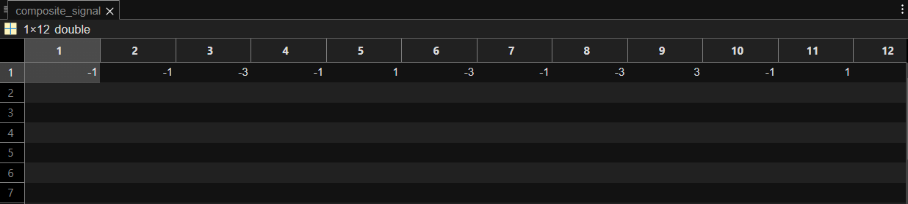

**Command Window:**

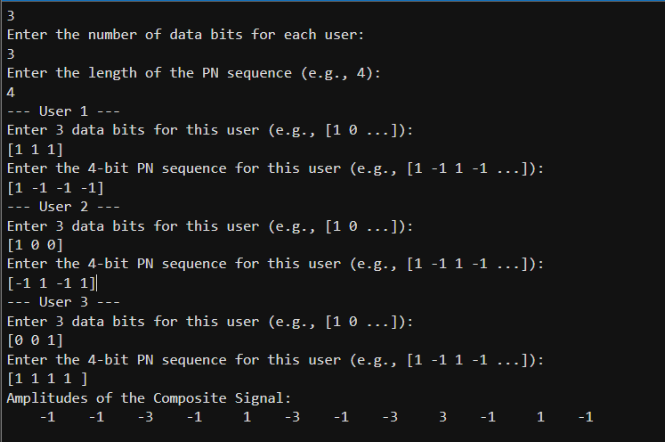

**Graphical Plot:**

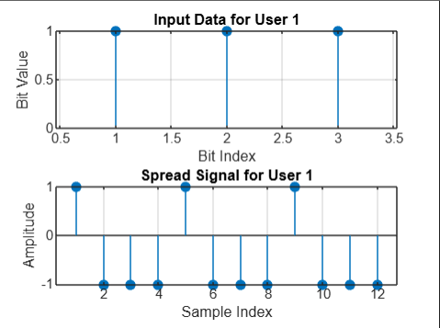

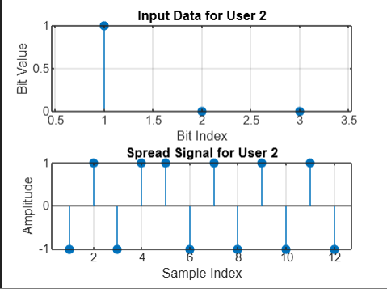

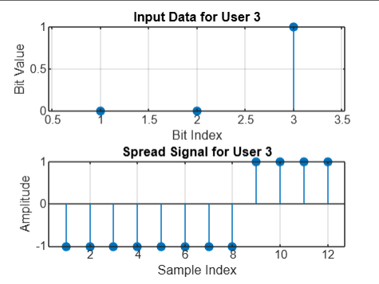



**CHAPTER 9**

**CONCLUSION**

This project explored the design and implementation of a Code Division Multiple Access (CDMA) transmitter, crucial for modern wireless communications. CDMA allows multiple users to share the same channel without significant interference through unique spreading codes. By spreading user data over a wide bandwidth, CDMA enhances the security and robustness of transmitted signals.

The MATLAB simulation illustrated the generation of binary data for several users and their modulation with orthogonal codes, demonstrating how distinct signals can coexist without interference. CDMA’s resilience to noise and capacity for numerous users make it ideal for mobile environments, maximizing bandwidth utilization.

However, challenges such as the near-far problem necessitate techniques like power control and advanced error correction. Overall, the CDMA transmitter effectively balances user capacity, signal integrity, and interference resistance. As telecommunications evolve, CDMA remains foundational for technologies like 3G and 4G, with future advancements focused on optimizing efficiency and integrating with new technologies to meet the growing demand for high-speed data communication.

**CHAPTER 10**

**REFERENCES**

*Proakis, J. G., & Salehi, M. (2007). Digital Communications (5th ed.). McGraw-Hill.*

*Ali, M. A. (2019). "Performance Analysis of CDMA Systems with Different Spreading Codes." Master’s Thesis, University of Technology.*

*Verma, A. K., & Shukla, S. (2013). "Performance Evaluation of CDMA System Under Various Spreading Codes." International Journal of Computer Applications, 71(9), 1-6.*